SUPPLEMENTARY DATA
Supplementary Data are available at NAR online.
SUPPLEMENTARY TABLE
Supplementary Table S1. Dz with indicated length (nt) and melting temperature (T_{m}) of DNA/RNA-hybridizing arms. T_{m} was determined by Mfold using the following parameters: T = 37 ºC, [Na⁺] = 165 mM, [Mg²⁺] = 2 mM.

Dz1 name | RNA-hybridizing arm lengths (-nt) |  | Tm (°C) of RNA hybridizing arms | Dz2 name | RNA-hybridizing arm lengths (-nt) |  | Tm (°C) of RNA-binding arms (x/y)
Dz1 name | Arm 1 | Arm 2 | (Arm 1/ Arm 2) | Dz2 name | Arm 1 | Arm 2 | (Arm 1/ Arm 2)
RNA-58
Dz1_11/10 | 11 | 10 | 26/32 | Dz2_11/8 | 11 | 8 | 34/28
Dz1_10/11 | 10 | 11 | 23/32 | Dz2_10/9 | 10 | 9 | 29/35
Dz1_10/10 | 10 | 10 | 23/26 | Dz2_10/8 | 10 | 8 | 29/28
Dz1 | 11 | 11 | 32/32 | Dz2 | 11 | 9 | 34/35
Dz1_12/11 | 12 | 11 | 40/32 | Dz 2_11/10 | 11 | 10 | 34/39
Dz1_11/12 | 11 | 12 | 32/38 | Dz2_12/9 | 12 | 9 | 41/35
Dz1_12/12 | 12 | 12 | 40/38 | Dz2_12/10 | 12 | 10 | 41/39
Dz1_12/13 | 12 | 13 | 40/42 | Dz2_13/10 | 13 | 10 | 45/39
Dz1_13/12 | 13 | 12 | 46/38 | Dz2_12/11 | 12 | 11 | 41/41
Dz1_13/13 | 13 | 13 | 46/42 | Dz2_13/11 | 13 | 11 | 45/41
RNA-104
Dz3 | 11 | 12 | 32/33 | - | - | - | -
RNA-60
60_Dz1_11/11 | 10 | 10 | 31/34 | 60_Dz2_10/12 | 10 | 12 | 35/36

Supplementary Table S2. Melting temperatures of the tile strands for the two-component BDDs.

Name of BDD | Composing oligonucleotides | Sequence 5’ –> 3’ | T_{m} of dsDNA platform (°C)
BDD2 | BDD2_Dz1 | CATGGCAAACA A GGC TAG CTA CAA CGA CATATCGGTGC /HEG/ G CACCG TTACG AGTGG CAGCA ACAGA ACATG | 75
BDD2 | BDD2_Dz2 | TCGAGCCGC A GGC TAG CTA CAA CGA CGGTAGCTCTC /HEG/ CATGT TCTGT TGCTG CCACT CGTAA CGGTG C | 75
BDD3 | BDD3_Dz1 | CATGGCAAACA A GGC TAG CTA CAA CGA CATATCGGTGC /HEG/ G CAGCA ACAGA A | 38
BDD3 | BDD3_Dz2 | T TCTGT TGCTG C /HEG/ TCGAGCCGC A GGC TAG CTA CAA CGA CGGTAGCTCTC | 38
BDD4 | BDD4_Dz1 | CATGGCAAACA A GGC TAG CTA CAA CGA CATATCGGTGC /HEG/ CG TGCTA CTGTACT | 36
BDD4 | BDD4_Dz2 | AGTACTGTAGCACG /HEG/ TCGAGCCGC A GGC TAG CTA CAA CGA CGGTAGCTCTC | 36
BDD5 | BDD5_Dz1 | CATGGCAAACA A GGC TAG CTA CAA CGA CATATCGGTGC /HEG/ CG TGCTA CAGTACT | 43
BDD5 | BDD5_Dz2 | AGTACTGTAGCACG /HEG/ TCGAGCCGC A GGC TAG CTA CAA CGA CGGTAGCTCTC | 43
BDD6 | BDD6_Dz1 | CAT GGC AAA CAA GGC TAG CTA CAA CGA CATATCGGTGC /HEG/ CG TGC TAC AGT ACT CATCA ACC AGA ACA TGC C | 70
BDD6 | BDD6_Dz2 | GGCATGTTCTGGT TGATGAGTAC TGTAGCACG /HEG/ TCGAGCCGC A GGC TAG CTA CAA CGA CGGTAGCTCTC | 70
60_BDD2 | 60_BDD2_Dz1 | ACAAGCAATCA A GGC TAG CTA CAA CGA CAGAACAACTT /HEG/ G CACCG TTACG AGTGG CAGCA ACAGA ACATG | 75
60_BDD2 | 60_BDD2_Dz2 | AGACCTTTAGTG A GGC TAG CTA CAA CGA TGAGGTGTGG /HEG/ CATGT TCTGT TGCTG CCACT CGTAA CGGTG C | 75
60_BDD3 | 60_BDD3_Dz1 | ACAAGCAATCA A GGC TAG CTA CAA CGA CAGAACAACTT /HEG/ G CAGCA ACAGA A | 38
60_BDD3 | 60_BDD3_Dz2 | T TCTGT TGCTG C /HEG/ AGACCTTTAGTG A GGC TAG CTA CAA CGA TGAGGTGTGG | 38
The dsDNA platform forming nucleotides are in green;
Red underlined are mismatched nucleotides;
Dz 10-23 catalytic cores are in bold;
HEG is hexamethylene glycol inkers.

Supplementary Table S3. Oligonucleotides used in the study.

Name | Sequence 5’ – 3’ | Purification
RNA-58 | FAM-acg aga gcu acc ggu gcg gcu cga cca aga gcg cac cga uau ggu ugu uug cca ugg u | PAGE
RNA-104 | cgu ucg aac gag agc uac cgg ugc ggc ucg acc aag agc gca ccg aua ugg uug uuu gcc aug gug auc ccu gca ugg uga acu uca ugg ugc guu cga cac g | PAGE
RNA-60 | FAM-uaa acc aca ccu caguca cua aag guc ugu uua aag uug uuc ugguug auu gcu ugu u | PAGE
BDD1 | CATGGCAAACA A GGC TAG CTA CAA CGA CATATCGGTGC /HEG/ TCGAGCCGC A GGC TAG CTA CAA CGA CGGTAGCTCTC’ | PAGE
BDD3_Dz1 | CATGGCAAACA A GGC TAG CTA CAA CGA CATATCGGTGC /HEG/ G CAGCA ACAGA A | PAGE
BDD3_Dz2 | T TCTGT TGCTG C /HEG/ TCGAGCCGC A GGC TAG CTA CAA CGA CGGTAGCTCTC | PAGE
BDD2_Dz1 | CATGGCAAACA A GGC TAG CTA CAA CGA CATATCGGTGC /HEG/ G CACCG TTACG AGTGG CAGCA ACAGA ACATG | PAGE
BDD2_Dz2 | TCGAGCCGC A GGC TAG CTA CAA CGA CGGTAGCTCTC /HEG/ CAT GTT CTG TTG CTG CCA CTC GTA ACG GTG C | PAGE
BDD4_Dz1 | CATGGCAAACA A GGC TAG CTA CAA CGA CATATCGGTGC /HEG/ CGTGCTA CTGTACT | PAGE
BDD4_Dz2 | AGTACTGTAGCACG /HEG/ TCGAGCCGC A GGC TAG CTA CAA CGA CGGTAGCTCTC | PAGE
BDD5_Dz1 | CATGGCAAACA A GGC TAG CTA CAA CGA CATATCGGTGC /HEG/ CG TGCTACAGTACT | PAGE
BDD5_Dz2 | AGTACTGTAGCACG /HEG/ TCGAGCCGC A GGC TAG CTA CAA CGA CGGTAGCTCTC | PAGE
BDD6_Dz1 | CATGGCAAACA A GGC TAG CTA CAA CGA CATATCGGTGC /HEG/ CG TGCTACAGTACT CATCA ACCAGA ACATGCC | PAGE
BDD6_Dz2 | GGCATGTTCTGGT TGATGAGTAC TGTAGCACG /HEG/ TCGAGCCGC A GGC TAG CTA CAA CGA CGGTAGCTCTC’ | PAGE
Dz1 | CATGGCAAACA A GGC TAG CTA CAA CGA CATATCGGTGC | PAGE
Dz2 | TCGAGCCGC A GGC TAG CTA CAA CGA CGGTAGCTCTC’ | PAGE
Dz2_11/8 | CGAGCCGC A GGC TAG CTA CAA CGA CGGTAGCTCTC’ | PAGE
Dz2_10/9 | TCG AGC CGC A GGC TAG CTA CAA CGA CGGTA GCTCT’ | PAGE
Dz2_10/8 | CGA GCC GC A GGC TAG CTA CAA CGA CGGTAG CTCT | PAGE
Dz1_11/10 | ATGGCAAACA A GGC TAG CTA CAA CGA CATATCGGTGC’ | PAGE
Dz1_10/11 | CATGGCAAACA A GGC TAG CTA CAA CGA CATATCGGTG | PAGE
Dz1_10/10 | ATGGCAAACA A GGC TAG CTA CAA CGA CATATCGGTGC’ | PAGE
Dz1_12/11 | CATGGCAAACA A GGC TAG CTA CAA CGA CATATCGGTGCG’ | PAGE
Dz1_11/12 | CCATGGCAAACA A GGC TAG CTA CAA CGA CATATCGGTGC | PAGE
Dz1_12/12 | CCATGGCAAACA A GGC TAG CTA CAA CGA CATATCGGTGCG’ | PAGE
Dz2_11/10 | GTCGAGCCGC A GGC TAG CTA CAA CGA CGGTAGCTCTC | PAGE
Dz2_12/9 | TCGAGCCGC A GGC TAG CTA CAA CGA CGGTAGCTCTCG | PAGE
Dz2_12/10 | GTCGAGCCGC A GGC TAG CTA CAA CGA CGGTAGCTCTCG | PAGE
Dz2_13/10 | GTC GAG CCGC A GGC TAG CTA CAA CGA CGGT AGCTCTCGT | PAGE
Dz2_12/11 | GGTCGAGCCGC A GGC TAG CTA CAA CGA CGGTAGCTCTCG | PAGE
Dz2_13/11 | GGT CGA GCC G C A GGC TAG CT A CAA CGA CGG TAGCTCTCGT | PAGE
Dz1_12/13 | ACCATGGCAAACA A GGC TAG CTA CAA CGA CATATCGGTGCG | PAGE
Dz1_13/12 | CCATGGCAAACA A GGC TAG CTA CAA CGA CATATCGGTGCGC | PAGE
Dz1_13/13 | ACCATGGCAAACA A GGC TAG CTA CAA CGA CATATCGGTGCGC | PAGE
BDD1-o | CCATGGCAAACA A GGC TAG CTA CAA CGA CATATCGGTGCGC /HEG/ GGTCGAGCCGC A GGC TAG CTA CAA CGA CGGTAGCTCTCG | PAGE
BDD1-s | ATGGCAAACA A GGC TAG CTA CAA CGA CATATCGGTG /HEG/  CGAGCCGC A GGC TAG CTA CAA CGA CGGTAGCTCT’ | PAGE
BDD1_1A | CATGGCAAACA A GGC TAG CTA CAA CGA CATATAGGTGC /HEG/ TCGAGCCGC A GGC TAG CTA CAA CGA CGGTAGCTCTC’ | PAGE
BDD1_2’A | CATGGCAAACA A GGC TAG CTA CAA CGA CATATCGGTGC /HEG/ TCGAACCGC A GGC TAG CTA CAA CGA CGGTAGCTCTC | PAGE
BDD1_12’A | CATGGCAAACA A GGC TAG CTA CAA CGA CATATAGGTGC /HEG/ TCGAACCGC A GGC TAG CTA CAA CGA CGGTAGCTCTC | PAGE
BDD1-I | CATGGCAAACA A GGC (I)AG CTA CAA CGA CATATCGGTGC /HEG/ TCGAGCCGC A GGC TAG CTA CAA CGA CGGTAGCTCTC | PAGE
BDD3_1A | CATGGCAAACA A GGC TAG CTA CAA CGA CATATAGGTGC /HEG/ G CAGCG TTACG A | PAGE
BDD3_2’A | T CGTAA CGGTG C /HEG/ TCGAACCGC A GGC TAG CTA CAA CGA 5’ - CGGTAGCTCTC | PAGE
BDD4_1A | CATGGCAAACA A GGC TAG CTA CAA CGA CATATAGGTGC /HEG/ G CACCG TTACG A | PAGE
BDD4_2’A | T CGTAA CGGTG C /HEG/ TCGAACCGC A GGC TAG CTA CAA CGA CGGTAGCTCTC | PAGE
BDD5_1A | CATGGCAAACA A GGC TAG CTA CAA CGA CATATAGGTGC /HEG/ CG TGCTACAGTACT | PAGE
BDD5_2’A | AGTACTGTAGCACG /HEG/ TCGAACCGC A GGC TAG CTA CAA CGA CGGTAGCTCTC | PAGE
BDD6_1A | CATGGCAAACA A GGC TAG CTA CAA CGA CATATAGGTGC /HEG/ CG TGCTACAGTACT CATCA ACCAGA ACATGCC | PAGE
BDD6_2’A | GGCATGTTCTGGT TGATGAGTAC TGTAGCACG /HEG/ TCGAACCGC A GGC TAG CTA CAA CGA CGGTAGCTCTC | PAGE
Dz1_1A | CAT GGC AAA CA A GGC TAG CTA CAA CGA CAT ATA GGT GC | PAGE
Dz2_2’A | TCG AAC CGC A GGC TAG CTA CAA CGA CG GTA GCT CTC | PAGE
Dz1-I | CATGGCAAACA A GGC (I) AG CTA CAA CGA CATATCGGTGC | PAGE
Dz3 | ACCATGAAGTTC A GGC TAG CTA CAA CGA CATGCAGGGAT | PAGE
104_TDD | ACCATGAAGTTC A GGC TAG CTA CAA CGA CATGCAGGGAT \HEG\ CATGGCAAACA A GGC TAG CTA CAA CGA CATATCGGTGC /HEG/ TCGAGCCGC A GGC TAG CTA CAA CGA CGGTAGCTCTC | PAGE
104_BDD1(2) | ACCATGAAGTTC A GGC TAG CTA CAA CGA CATGCAGGGAT \HEG\ CATGGCAAACA A GGC TAG CTA CAA CGA CATATCGGTGC | PAGE
60_BDD1 | AGGAGCTCAA A GGC TAG CTA CAA CGA TCTTCCAGGC /HEG/ TTGGTGACATC A GGC TAG CTA CAA CGA GAATCTTCATGG | PAGE
60_BDD2_Dz1 | ACAAGCAATCA A GGC TAG CTA CAA CGA CAGAACAACTT /HEG/ G CAGCA ACAGA A | PAGE
60_BDD2_Dz2 | T TCTGT TGCTG C /HEG/ AGACCTTTAGTG A GGC TAG CTA CAA CGA TGAGGTGTGG | PAGE
60_BDD3_Dz1 | ACAAGCAATCA A GGC TAG CTA CAA CGA CAGAACAACTT /HEG/ G CAGCA ACAGA A | PAGE
60_BDD3_Dz2 | T TCTGT TGCTG C /HEG/ AGACCTTTAGTG A GGC TAG CTA CAA CGA TGAGGTGTGG | PAGE
60_Dz1_11/11 | ACAAGCAATCA A GGC TAG CTA CAA CGA CAGAACAACTT | PAGE
60_Dz1_ 10/12 | AGACCTTTAGTG A GGC TAG CTA CAA CGA TGAGGTGTGG | PAGE
Inner Control (IC) | C AGT CGA CTC GCC GAT TAG ACG AAC A | PAGE
RNA nucleotides are in low cases;
rGrU cleavage sites are in red;
Dz 10-23 catalytic cores are in bold;
HEG is hexamethylene glycol linkers.

SUPPLEMENTARY FIGURES

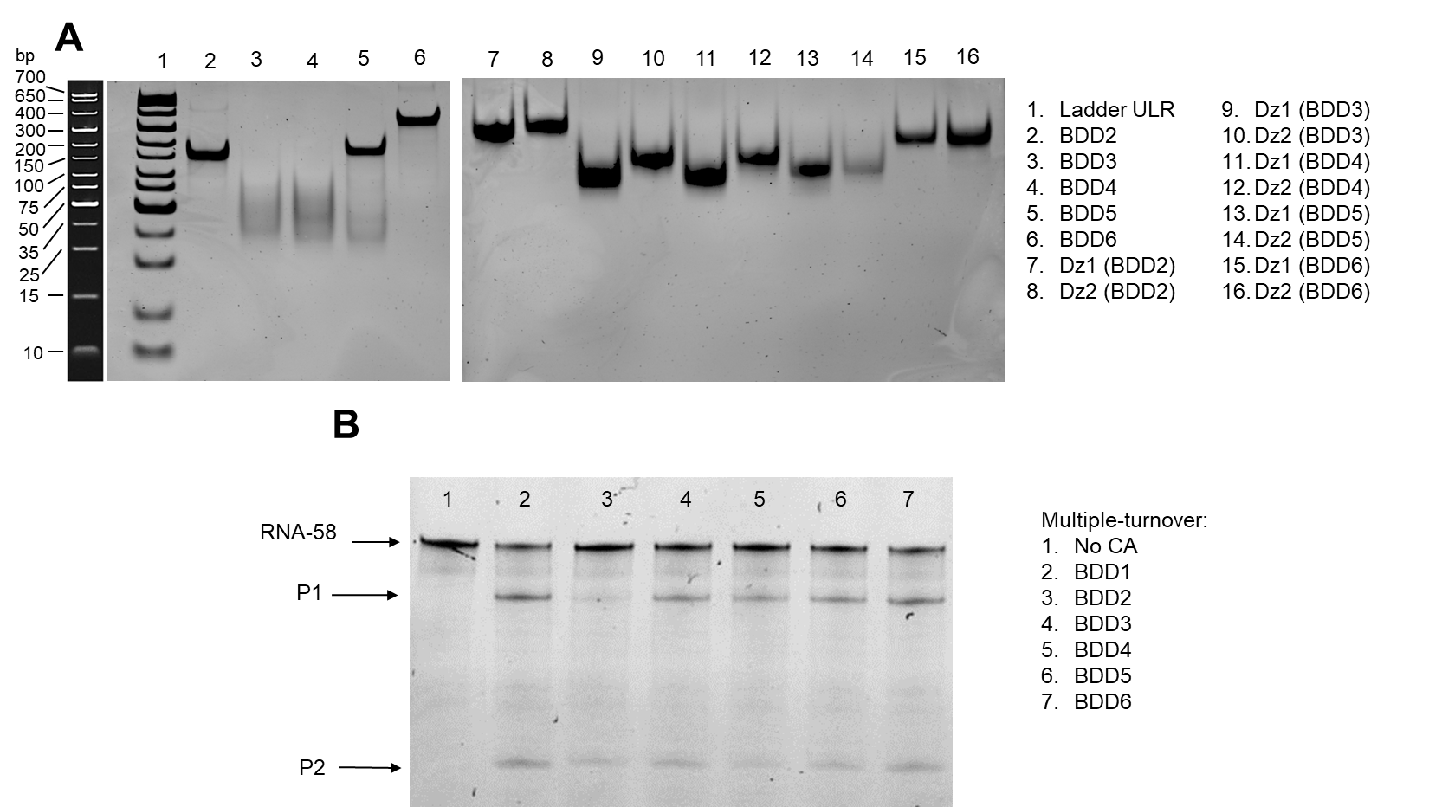

Supplementary Figure S1. A. Native 20% PAGE demonstrating the assembled two-component BDDs (BDD2–BDD6 in wells 1–6) and Dz parts composing BDDs (wells 7–16). The gels were stained with GelRed. TryDye ULR 10–700 bp was used as the ladder (Line 1). The size of the product bands is given according to the reference photo obtained from the official web page of the ladder. (https://www.neb.com/en/products/n0558-tridye-ultra-low-range-dna-ladder#Product%20Information);
B. A representative image from the analysis of the products of RNA-58 cleavage by 6 variants of bivalent CA (BDD1–BDD6) after 5 h under multiple-turnover conditions using denaturing PAGE. The PAGE images correspond to the data in Figure 5 of the main text.
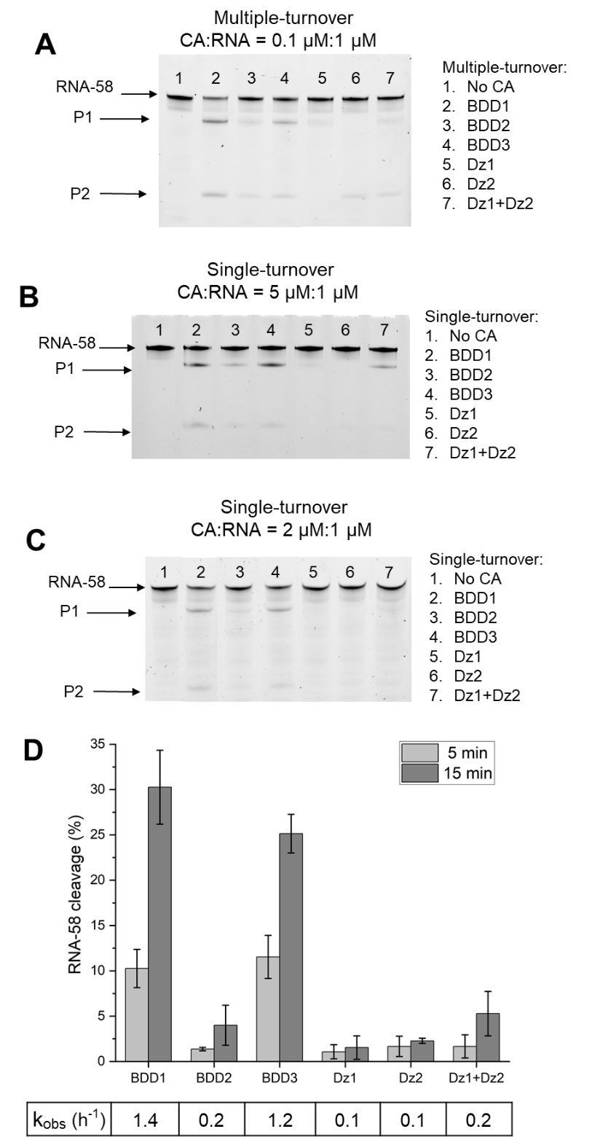
Supplementary Figure S2. RNA-58 cleavage by BDD and Dz. Panels A–C: representative images for the analysis of the cleavage products by 20% denaturing PAGE. The bands were visualized 5’ FAM-labelled RNA substrate. Panel D: percent efficiency of RNA cleavage under single-turnover conditions. A. Multiple-turnover conditions after 5 h. B. Single-turnover conditions with 5 μM cleaving agents (CA) and 1 μM RNA-58 after 15 min. C. Single-turnover conditions with 2 μM CA and 1 μM RNA after 15 min. D. Single-turnover conditions with 2 μM CA and 1 μM RNA-58 enzymes after 5 and 15 min of incubation. CA – cleavage agents (BDDs or Dz). RNA-58 and its cleavage products P1 and P2 are indicated by arrows. The PAGE images correspond to the data shown in Figure 3 of the main text.
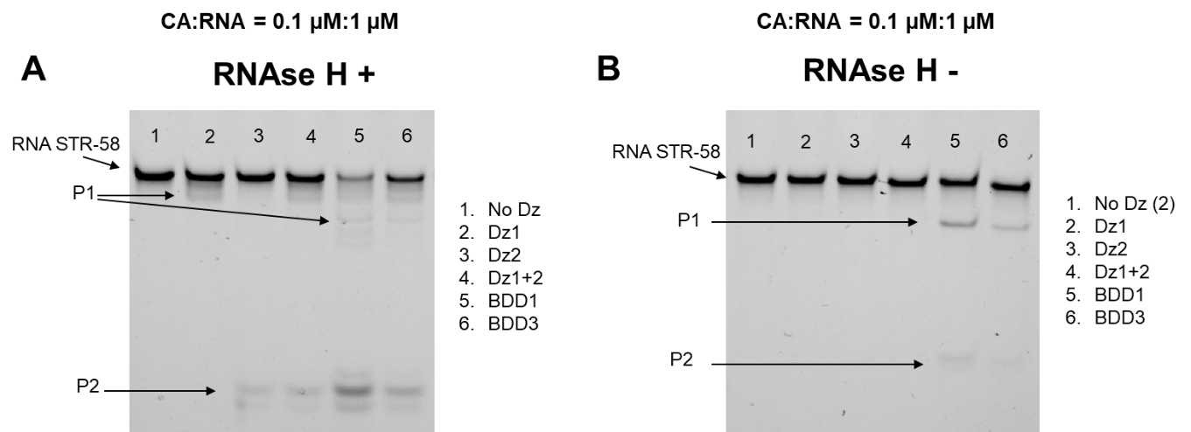

Supplementary Figure S3. Representative gel images after denaturing 20% PAGE analysis of RNA-58 cleavage products under multiple-turnover conditions after 20 min. A. With RNase H. B. Without RNase H. The PAGE images correspond to the data shown in Figure 4 of the main text.
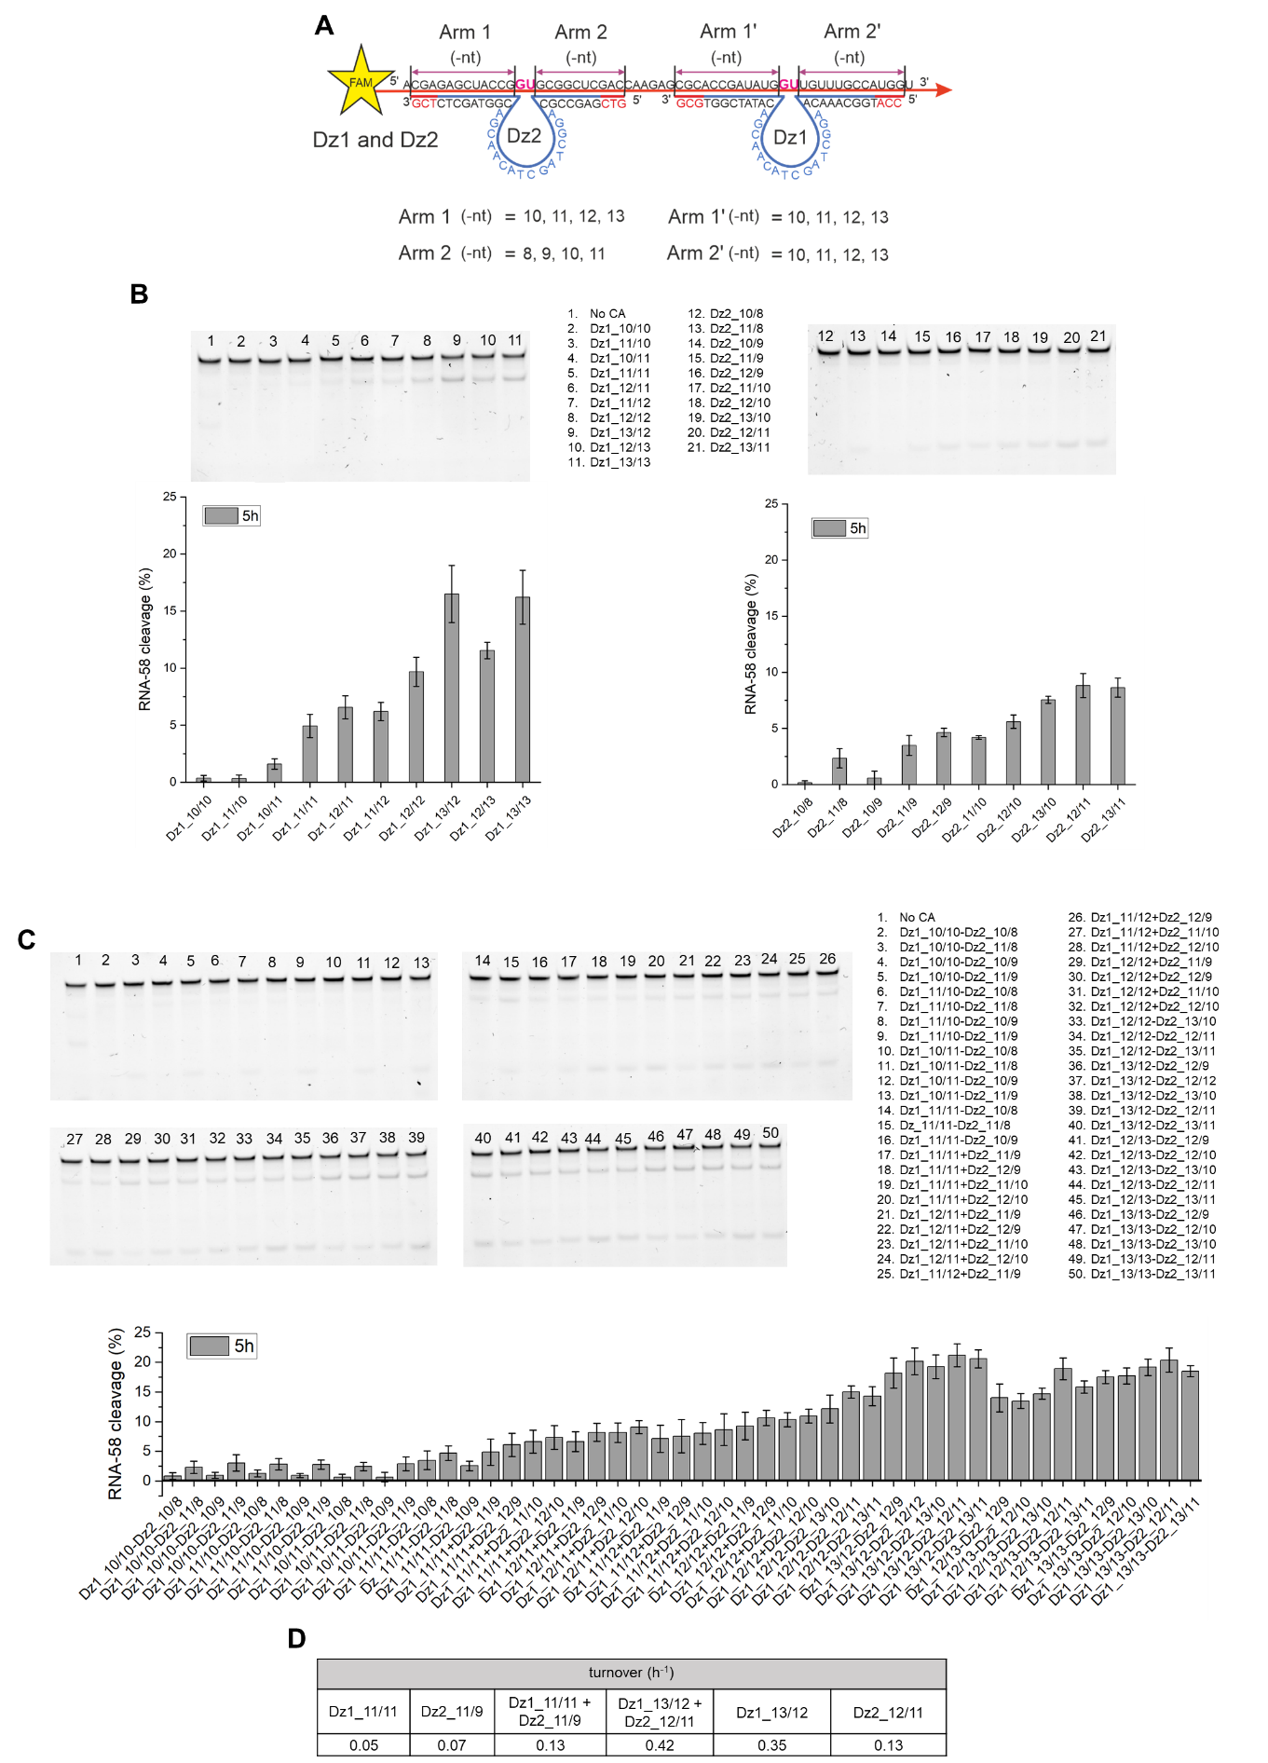
Supplementary Figure S4. Optimization of the lengths of RNA-hybridizing arms of Dz1 and Dz2. A. - Design of Dz with variable RNA-hybridizing arms. B. and C. Representative gel images after denaturing PAGE and percent of RNA cleavage by the indicated Dz acting separately (B) or cooperatively (C). D. Values for TON calculated for the initial and optimized Dz.
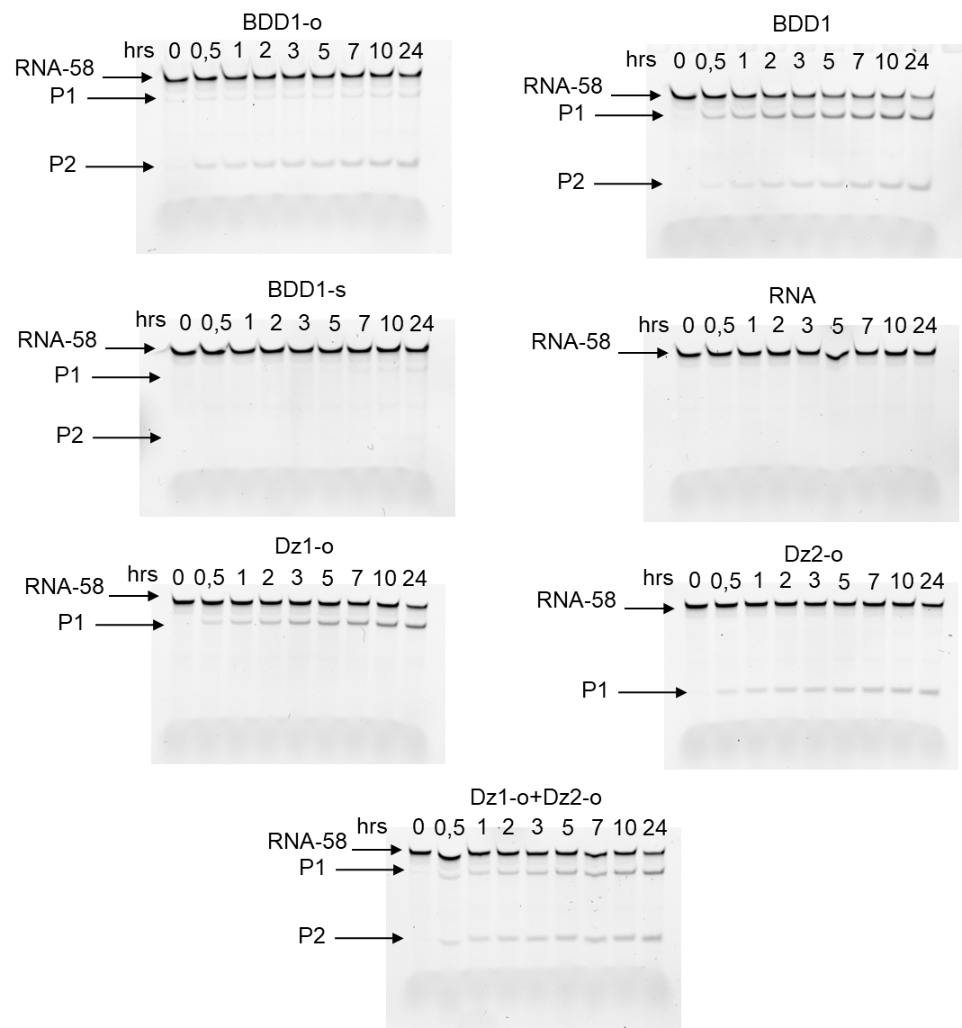
Supplementary Figure S5. Representative gel images after denaturing 20% PAGE analysis of RNA-58 cleavage products in the presence of the indicated CA at different time points. The optimized Dz were used as positive controls. RNA-58 and its cleavage products P1 and P2 are indicated by arrows. The results correspond to Figure 6B of the main text.
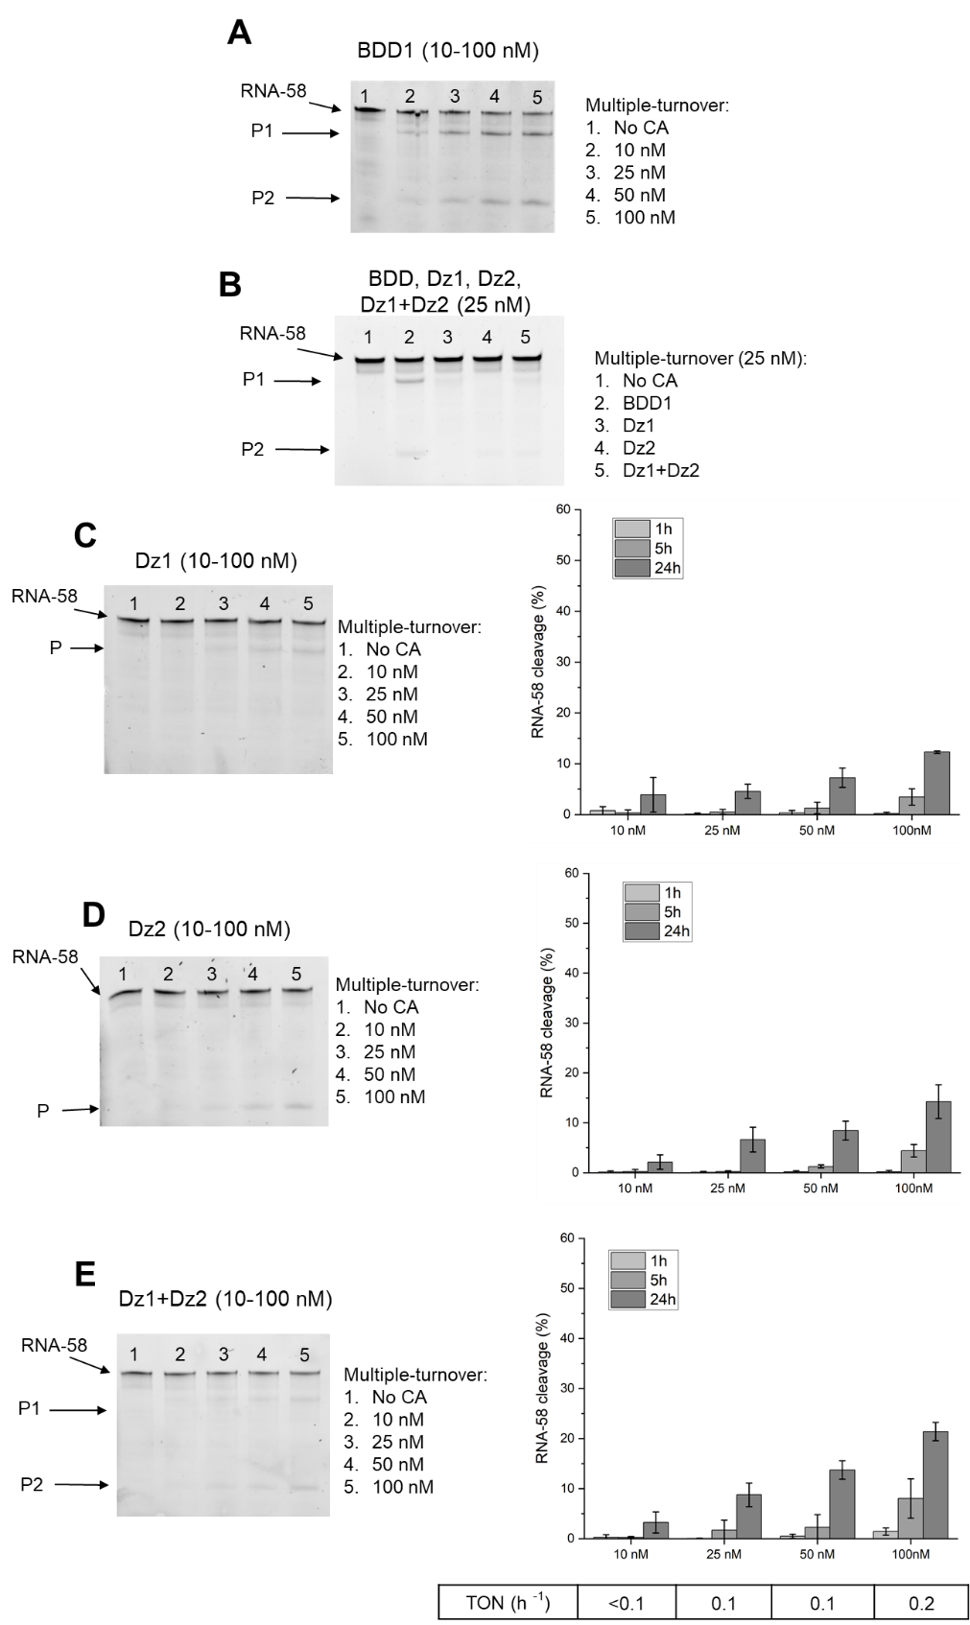

Supplementary Figure S6. Analysis of concentration-dependent kinetics for the cleavage of RNA-58 (1 μM RNA) by the indicated BDDs and Dz. A. BDD1 as a cleaving agent at 10, 25, 50 or 100 nM B. BDD1, Dz1, Dz2 or Dz1+Dz2 were used as cleaving agents at 25 nM. C. Dz1 was used at 10, 25, 50 or 100 nM, D. Dz2 was used at 10, 25, 50 or 100 nM. E. Dz1+Dz2 tandem used at 10, 25, 50 or 100 nM RNA-58 and its cleavage products P1 and P2 are indicated by arrows in the gels. The gels in panels A and B correspond to Figure 7 of the main text.

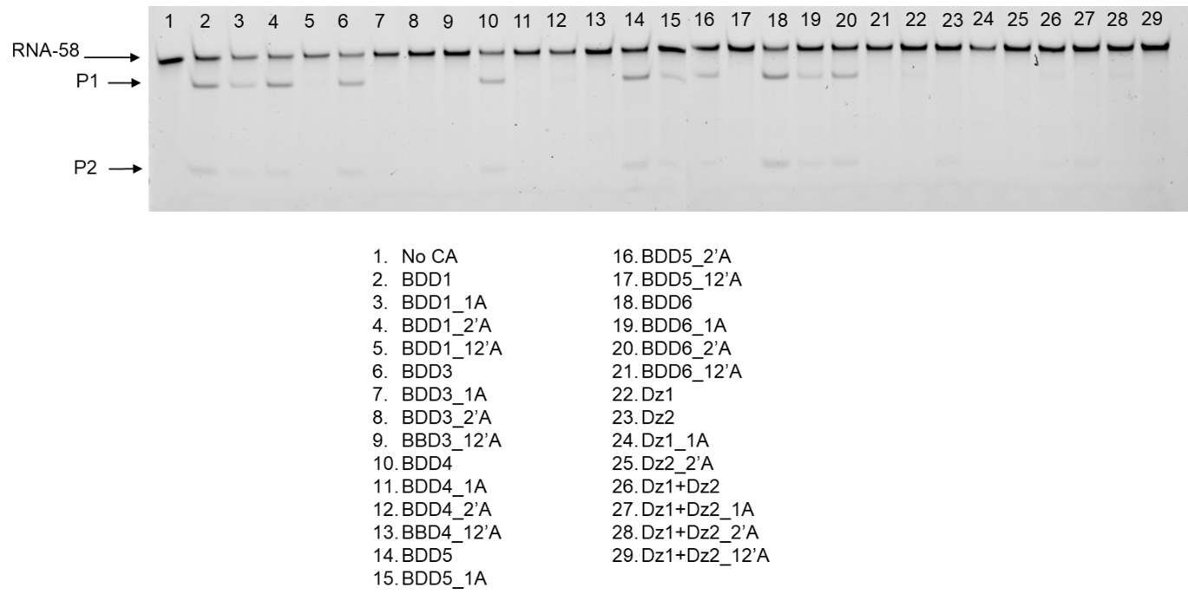
Supplementary Figure S7. Representative denaturing PAGE indicating the cleavage profile of fully matched and mismatched (mm) BDDs and Dz. RNA-58 and its cleavage products P1 and P2 are indicated by arrows in the gels. The PAGE results correspond to Figure 8 of the main text.

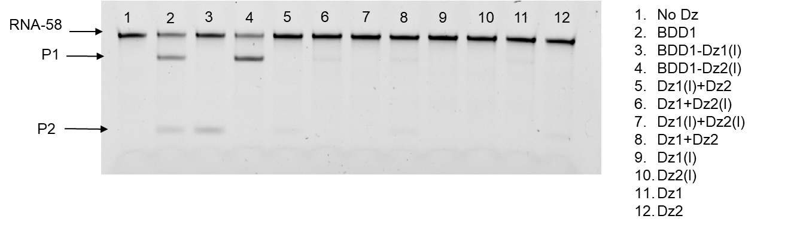
Supplementary Figure S8. Representative gel image after denaturing PAGE analysis of RNA-58 cleavage by i BDD or Dz agents (BDD-1, Dz1, Dz2) or deactivated (inosine-containing) Dz cores (Dz1-I, BDD1-I). RNA-58i and cleavage products P1 and P2 are indicated by arrows. The gel image is one of the three experiments used for calculating cleaved efficiencies shown in Figure 9 of the main text.
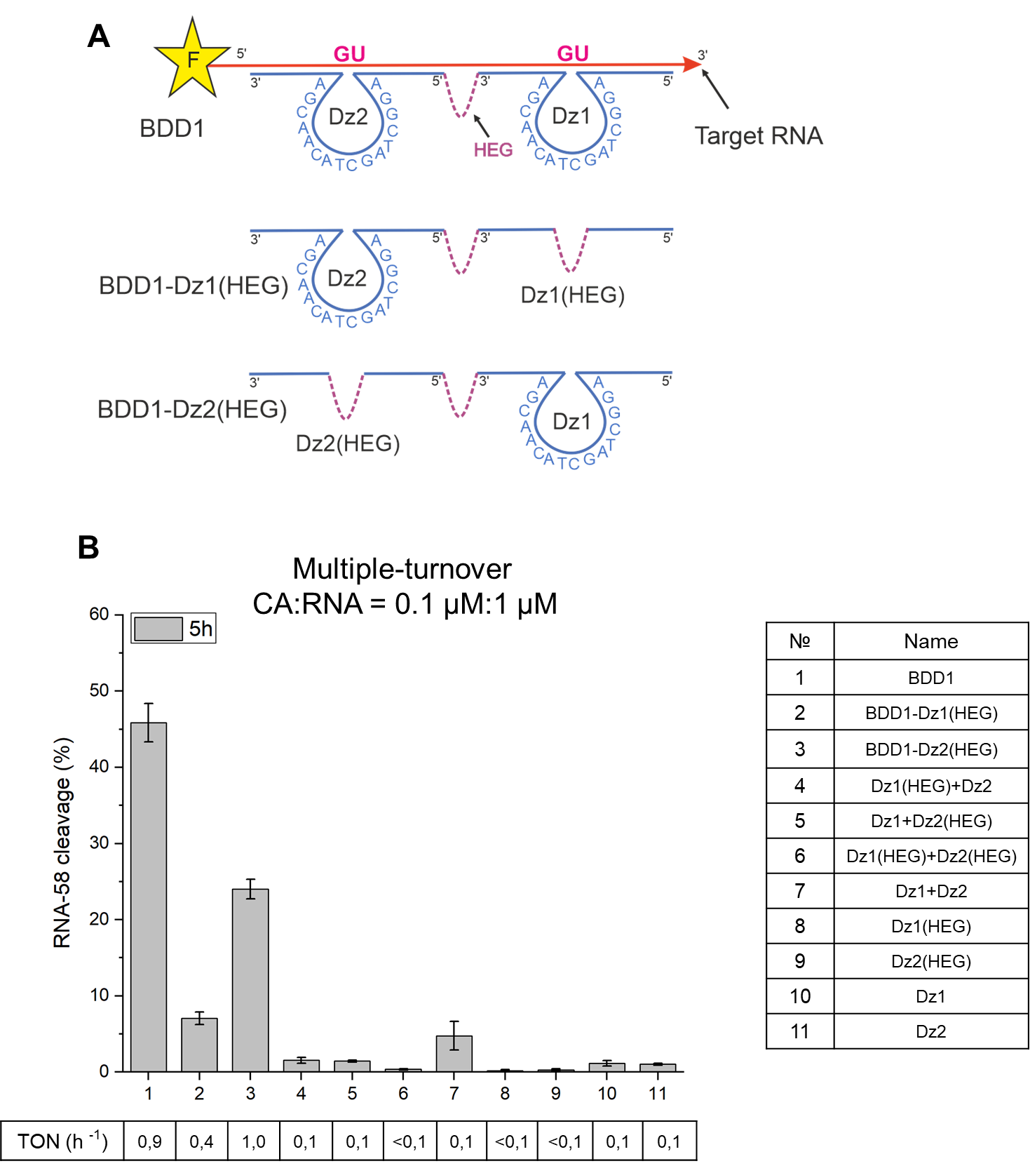
Supplementary Figure S9. The influence of RNA-binding arms on BDD/Dz-RNA turnover deletion of a catalytic core with polyethylene glycol (HEG) linker substitution. Both cooperative RNA binding and increased probability for RNA cleavage contribute to the increased efficiency of the bivalent agents in cleaving RNA-58. A. BDD1 with inactivated Dz1 or Dz2 catalytic core due to the substitution of essential T4 with inosine (I), as described earlier (35). B. Relative efficiency of RNA-58 cleavage by different Dz agents under multiple turnover conditions and correspondent values for turnover numbers (TON). The data is the averaged values of three independent experiments.
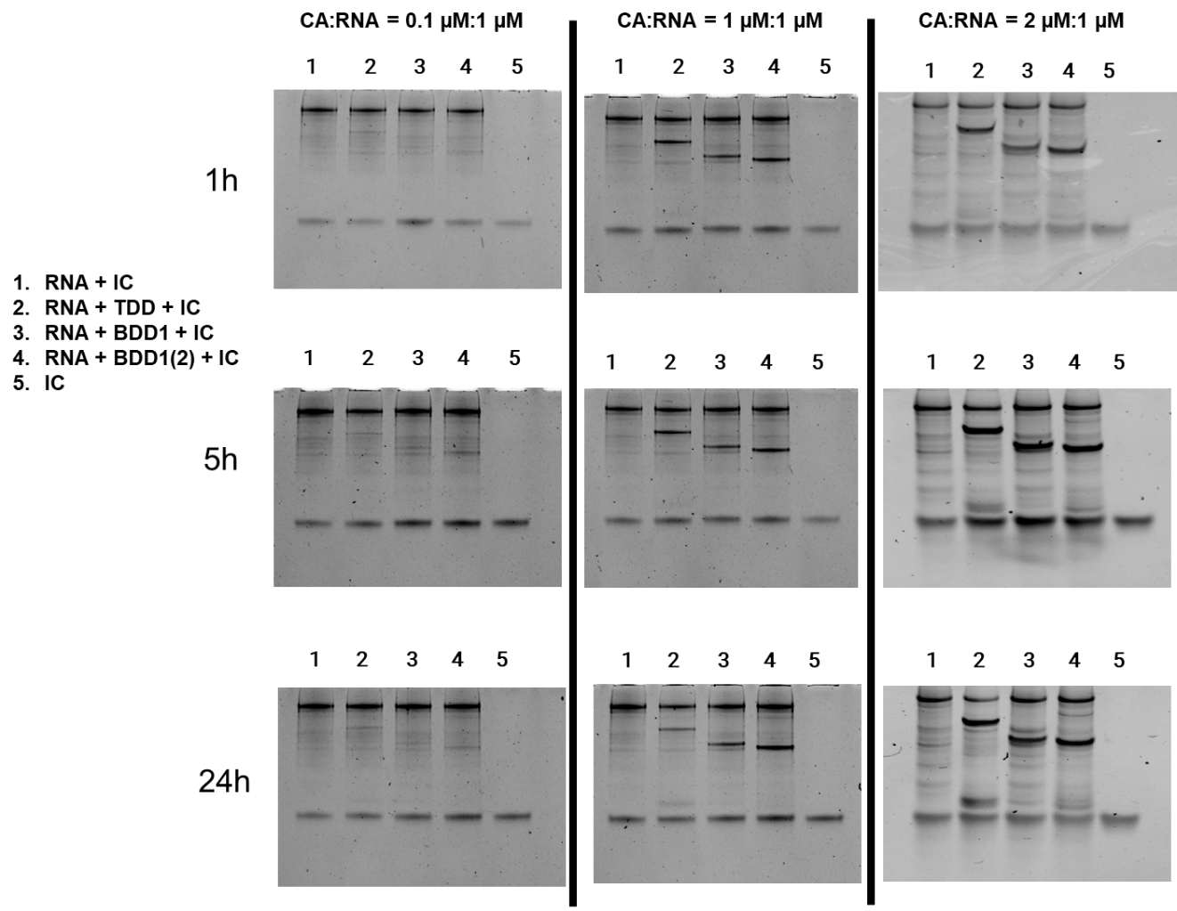

Supplementary Figure S10. Representative gel images after denaturing PAGE analysis of RNA-104 cleavage by cleaving agents (TDD, BDD1, BDD1(2)) with different CA:RNA concentration ratio: 0.1 μM:1 μM, 1 μM:1 μM, 2 μM:1 μM (CA – cleavage agent). IC – internal control, a 26-not deoxyribonucleotide was added to the sample to enable normalization of the band intensity by the concentration of the oligonucleotides loaded on the gel. The gel image corresponds to Figure 10.
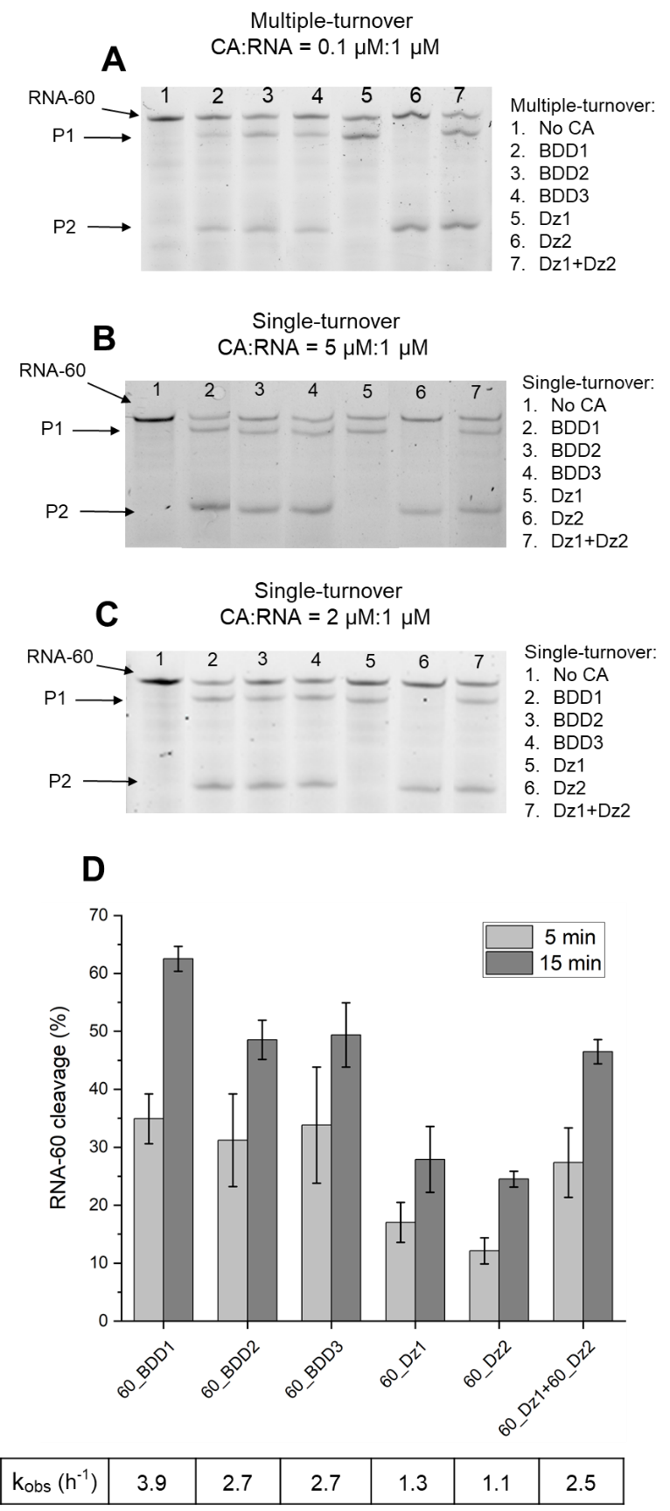
Supplementary Figure S11. Additional data on RNA-60 cleavage by BDD and Dz. Analysis of the cleavage products by 20% denaturing PAGE under different conditions (A–C) and percent of RNA cleavage under single-turnover conditions. A. Multiple-turnover conditions after 5 h. B. Single-turnover conditions with 5 μM CA and 1 μM RNA-60 after 15 min. C. Single-turnover conditions with 2 μM CA and 1 μM RNA-60 after 15 min. D. Percent of RNA-60 cleavage by the indicated cleaving agents under single-turnover conditions; 2 μM CA and 1 μM RNA-60 after 5 and 15 min of incubation. CA – cleavage agents BDDs or Dz. RNA-60 and its cleavage products P1 and P2 are indicated by arrows. The gel image corresponds to Figure 11 of the main text.

